Layer 7 load balancers

 Layer 7 load balancers have knowledge of  http

 dns

 ssl/tls

 In the following image is a need to host multiple applications behind load balancer and perform path

based routing 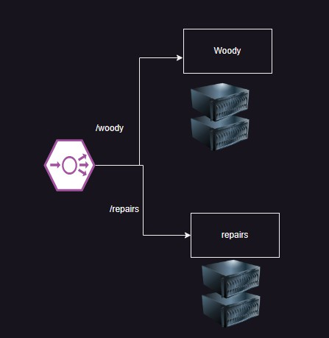

# AWS - Application Load Balancer

 This is layer 7 lb from aws  woody.sh

repairs.sh

#!/bin/bash

sudo apt update

sudo apt install nginx unzip -y cd /tmp

wget [https://www.free-css.com/assets/files/free-css-](http://www.free-css.com/assets/files/free-css-) templates/download/page294/woody.zip

unzip woody.zip

sudo mv carpenter-website-template/ /var/www/html/woody

#!/bin/bash

sudo apt update

sudo apt install nginx unzip -y cd /tmp

wget [https://www.free-css.com/assets/files/free-css-](http://www.free-css.com/assets/files/free-css-) templates/download/page296/inance.zip

unzip inance.zip

sudo mv inance-html/ /var/www/html/repairs

 We have create two ec2 instances with woody and two ec2 instances with repairs

 We have create a application load balancer, a listner to forward requests to woody target group while creation.

 Lets add a new target group for repairs  Now add rules

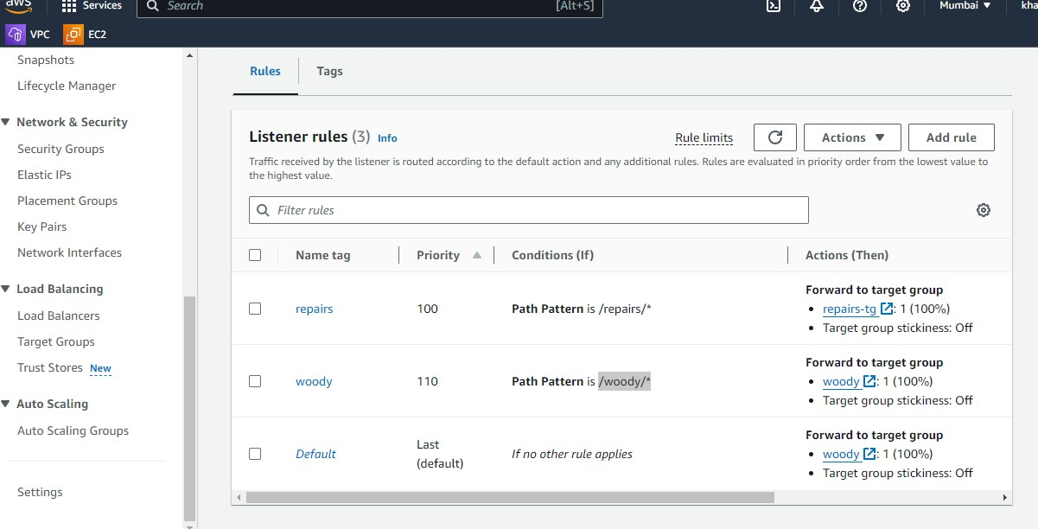

 For screenshots refer classroom video

# Azure Application Gateway

 This is Layer 7 LB offering from Azure  Lets create a network with 2 subnets

 Lets create two vms with woody in web subnet in different zones  Lets create two vms with repairs in web subnet in different zones

 Now create an Azure Application Gateway as discussed in the class